Curriculum Vitae
personal Information
Name | Hager Magdy Ramadan | 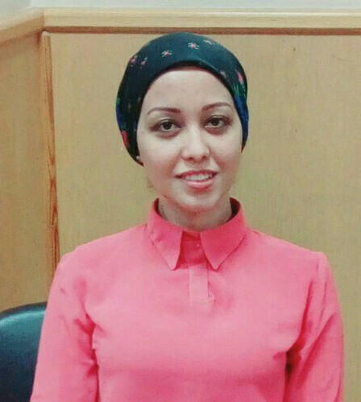
Title | Department of Physiology, Faculty of Veterinary Medicine, Cairo University.
Date of birth | 28th September, 1993.
Place of birth | Cairo
Citizenship | Egyptian
Contact Information
Home phone | ----------------
Work phone | 35720399
Mobile phone | (+20) 01011494147  (+20) 01159333706
E-mail (s) | hmagdy515@yahoo.com
Web site (s) | ----------
Current Address | Helwan- Cairo
Educational Qualifications
- M.V.Sc. physiology 2020, Faculty of Veterinary Medicine, Cairo University, Egypt
- B.V.Sc. 2016, Faculty of Veterinary Medicine, Cairo University, Egypt.
Academic Positions
- Assistant Lecturer (2020 –till now), Physiology Department, Faculty of Veterinary Medicine, Cairo University, Egypt

- Demonstrator (2017-2020), Department of Physiology, Faculty of Veterinary Medicine, Cairo University, Egypt

Thesis Title
- M.V.Sc. (2020): The ameliorating effect of melatonin hormone on the reproductive disorders and organ damage induced by hyperthyroidism in male rats.
Areas of experience
- Physiology.

- I am interested in endocrinology and reproduction and how we can develop new ways to battle some endocrine disorders.

- Usage of blackboard.

Professional Qualifications
- Training courses  - Use of Technology in Teaching.  Faculty and leadership Development center, Cairo university. | August 2019
- Critical Thinking.  Faculty and leadership Development center, Cairo university. | January 2020
- Effective teaching skills.  Faculty and leadership Development center, Cairo university. | February 2019
- Exams and students evaluation systems.  Faculty and leadership Development center, Cairo university. | September 2018
- International Publishing of Scientific Research.  Faculty and leadership Development center, Cairo university. | September 2019

- Egyptian Knowledge Bank (EKB) and Searching for sources.  Faculty and leadership Development center, Cairo university. | July 2017

- Financial and Legal Aspects of University Business.  Faculty and leadership Development center, Cairo university. | December 2020

- Work Stress Managment.  Faculty and leadership Development center, Cairo university. | January 2021

- Biostatistics (SPSS).  Postgraduate Studies and Research Sector of the Faculty of Veterinary Medicine, Cairo university. | November 2018
Computer skills
- Good command of computer skills (windows-internet-word-powerpoint-excel).

Language skills
- Good command of English both writing and speaking.

List of Publications:
- Ramadan, H.M., Taha, N.A. and Ahmed, H.H., 2020. Melatonin Improves Blood Biochemical Parameters and DNA Integrity in the Liver and Kidney of Hyperthyroid Male Rats. International Journal of Veterinary Science, 9(4): 511-516.

- Ramadan, H.M., Taha, N.A. and Ahmed, H.H., 2021. Melatonin enhances antioxidant defenses but could not ameliorate the reproductive disorders in induced hyperthyroidism model in male rats. Environmental Science and Pollution Research, 28(4), pp.4790-4804.

